The Rule of 2019 FIRA “RoboSot Parking Challenge”

Version – 1.1

**TASK**

Robot needs to race autonomously to complete 2 parking missions in the fastest time.

**RULES**

1. Every team is limited with one robot only. Robot used must be a Turtlebot 3 Burger.
2. Evaluation standard
   1. Each team will have 2 minutes to prepare and a maximum of 5 minutes to accomplish the mission.
   2. Each team will have 2 trials and the higher score will be used as the final score.
   3. Mission, deduction, and driving time points are ranked by summing scored.
3. Mission Point
   1. Every successful entry in parking space is 10 points.
   2. Every successful exit from parking space is 10 points.
   3. Successful in finishing the race is 50 points.
4. Deduction Points
   1. Each robot must stop for at least 3 seconds before exiting. Deduction of 2 points for each failure.
   2. Robot must finish the race within 5 minutes. The race is considered finish when the robot fully passed the finish line.
   3. Once the robot starts, 5 points will be deducted each time team member touch the robot.
5. Driving Time Points
   1. The team with the fastest driving time is given the highest score and differentiated by 1 point in chronological order.
   2. For example: If there are 15 teams running in this competition, 1st place is 15 points, 2nd place is 14 points, and the team with the slowest driving time will score 1 point.
6. Tiebreaker Regulations
   1. If there are more than 2 teams with the same final score, tiebreaker will be decided based on:
      1. Teams with least deductions
      2. Ranking highest to lowest in driving time points
7. Game Play
   1. Place the robot on the starting line and all team members should install their PC at the specified location.
   2. When the robot starts moving, the timer and game starts.
   3. If the robot is unable to accomplish a mission or leaves the driving course, you can ‘Time Out” to manually take care of your robot.
   4. The “Time Out” period will be included in the game time.
   5. The success of each mission is determined by the referee.
   6. If the mission is not accomplished within the 5 minutes running time, the game ends.

**Robots and System Configurations**

1. All teams must use the ROBOTIS TurtleBot3 Burger platform.
2. Robots must operate in autonomous mode using vision recognition systems and should not be controlled.
3. Robots can be customized but must comply with the exceptions below.
4. Exceptions when creating your robot :
   1. All teams must use the OpenCR controller and Dynamixel actuators from ROBOTIS
   2. To add-on driving devices, only Dynamixel can be used. (models do not matter)
5. There are no limits to the robot’s size and weight but should be built within the range that does not interfere with mission performance.
   1. Team server PC must be visible to the audience, except during the tunnel mission.
   2. Wireless routers and devices must be prepared by each teams.

**Playing Field & Size Restrictions**

1. Size : 6ft (L) x 6ft (W)
2. Material : 0.5-inch Plywood/Compress board
3. Floor Color : Black Carpet
4. Runway : 2-inch high surrounding wall
5. There are yellow and white lanes 1.5cm thick on both sides of the road.
6. Parking signs may be installed near parking spaces.

|  |  |
| --- | --- |
| Starting line | Parking Area |
|  |  |
| Parking (Mandatory) | |
|  | |

Figure 1: Line and sign specification

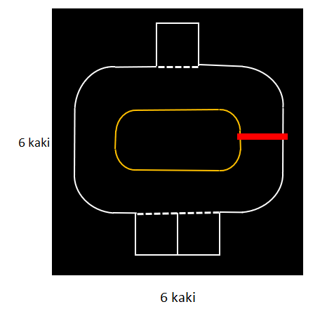

Figure 2. Playing Field Specification